

American International University-Bangladesh (AIUB)  
**Department of Computer Science  
Faculty of Science & Technology (FST)**

**Pet Buddy**

A Software Requirement Engineering Project Submitted

By

|  |  |  |  |  |
| --- | --- | --- | --- | --- |
| **Semester: Spring_22_23** | | **Section: E** | **Group Number: 08** | |
| SN | Student Name | Student ID | Contribution (CO1+CO2) | Individual Marks |
| 26 | Md. SAFIN | 19-41298-3 | Page 04 - 08 |  |
| 25 | NAZIA HASSAN | 19-41259-3 | Page 08 - 12 |  |
| 27 | ISRAT SHARMIN | 19-41328-3 | Page 13 - 17 |  |
| 21 | MD. ASIF CHOWDHURY | 19-40746-1 | Page 18 - 21 |  |

The project will be Evaluated for the following Course Outcomes

|  |  |  |
| --- | --- | --- |
| Evaluation Criteria | Total Marks (50) | |
|  | |
| Revision History, Test Plan Identifier, Reference Materials, Problem Background, Solutions | [10 Marks] |  |
| Requirements Specification (System feature, Quality Attributes, System Interface, Project Requirements) | [10 Marks] |  |
| Item Not to be tested, Testing approach (Testing levels, tools, meetings), Test cases | [10 Marks] |  |
| Item pass/fail criteria, Test deliverables, Staffing and Training, Responsibilities, Scheduling, Risk | [10 Marks] |  |
| Approval, Format, Submission, and Defense | [10 Marks] |  |

Software Test Plan

for

<Pet Buddy>

Version 1.0 approved.

Prepared by <Safin, Israt, Nazia, Asif>

<American International University - Bangladesh (AIUB)>

<29 April 2023 >

Table of Contents

Revision History 3

1. TEST PLAN IDENTIFIER: AT-TP01.3 4

2. REFERENCES 4

3. INTRODUCTION 4

3.1 Background to the Problem 4

3.2 Solution to the Problem 4

4. REQUEIREMNT SPECIFICATION 4

4.1 System Features 4

4.2 System Quality Attributes 5

4.3 System Interface 5

4.4 Project Requirements 5

5. FEATURES NOT TO BE TESTED 5

6. TESTING APPROACH 5

6.1 Testing Levels 5

6.2 Test Tools 6

6.3 Meetings 6

7. TEST CASES/TEST ITEMS 7

8. ITEM PASS/FAIL CRITERIA 7

9. TEST DELIVERABLES 7

10. STAFFING AND TRAINING NEEDS 8

11. RESPONSIBILITIES 8

12. TESTING SCHEDULE 8

13. PLANNING RISKS AND CONTINGENCIES 9

14. APROVALS 9

# Revision History

|  |  |  |  |
| --- | --- | --- | --- |
| Revision | Date | Updated by | Update Comments |
| 0.1 | 2023.03.13 | Md. Safin | First Draft |
| 0.2 | 2023.03.15 | Nazia Hassan | Second Draft |
| 0.3 | 2023.04.20 | Israt Sharmin | Third Draft |
| 0.4 | 2023.04.29 | Asif Chowdhury | Fourth Draft |

# TEST PLAN IDENTIFIER: PB01.1

# REFERENCES

* https://medium.com/@megan.jones38.mj/ui-ux-case-study-petcare-app-bb5fecf389f9
* https://www.google.com/url?sa=t&rct=j&q=&esrc=s&source=web&cd=&ved=2ahUKEwic8Z-Bjs_-AhUun2MGHexyCPAQFnoECA8QAQ&url=https%3A%2F%2Fcsns.cysun.org%2Fdepartment%2Fcs%2Fproject%2Fresource%2Fview%3FprojectId%3D6639295%26resourceId%3D6896491&usg=AOvVaw1zugby_QDBiFyB-NLgcvn4

# INTRODUCTION

## 3.1 Background to the Problem

In this 21st century, people love to have a pet but when it comes to taking care of the pets, the pet owner fails to do the necessary. In most circumstances, if any emergency occurs, a pet owner faces many challenges and has nothing to do. The biggest issue is getting to the veterans' doctors on time, feeding them nutritious food, and purchasing accessories and vaccination. Injured street animals also suffer as there is often no one to take care of them or provide them with immediate aid.

## 3.2 Solution to the Problem

To solve this problem, we are going to develop a system. The system called “Pet Buddy” Pet Buddy gives an environment to solve all these issues in one place.

The “Pet Buddy” system consists of five types of users. Users are the Owners of the pet, Veterinarians, Accessory shop owners, and Adoption center.

* + Owners of a pet can make appointments with the veterinarian.
  + Owners of a pet can buy necessary accessories from the listed accessory shop.
  + Owners of a pet can send requests for rescue.
  + Owners of a pet adopt pets.
  + Owners of a pet can get feeding and medication reminders for pets.
  + Owners of pet can search for another pets.
  + Accessory shop owners can manage pet accessories to the system.
  + Adoption center can enlist a pet in the system.
  + Adoption center can respond to adoption requests.
  + Adoption center can respond to a rescue request.
  + Volunteers can respond to any volunteering work from the adoption center.

# REQUEIREMNT SPECIFICATION

## System Features

**1. System Registration**  
Functional Requirements

* 1. The software shall allow users to register with the required information.
  2. If the username is new to the system, the system shall request the user to register with username and password.

Priority Level: High  
Precondition: Not applicable.

**2. Search for Pet Adoption**  
Functional Requirements

* 1. The software shall allow user and owner of the pets to search for pet adoption and adopt pets from the adopt center.

Priority Level: Low  
Precondition: user must have valid user id and password.

**3. Appointment with Veterinarians**   
Functional Requirements

* 1. The software shall allow owners of pet to take appointment and consult.
  2. Veterinarians shall interact with the requested user as per schedule for vaccination.

Priority Level: High  
Precondition: user must have valid user id and password.

**4. Purchase Accessories**  
Functional Requirements

* 1. The software shall allow owners of the pet to purchase accessory from the owner of the accessory shop.

Priority Level: Low  
Precondition: user must have valid user id and password.

**5. Request for Pet** **Rescue**  
Functional Requirements

* 1. The software shall allow owners of the pet users and guest user to request for rescue a pet, to the adopt center.
  2. The rescue location must be sent with the rescue request to the adopt center and without exact rescue location request for the rescue cannot be done.

Priority Level: Medium  
Precondition: user must have valid user id and password.

**6. Manage Pet Accessories**  
Functional Requirements

* 1. The software shall allow the accessory shop owners to enlist accessories to the system.
  2. The accessory shop owner will be able to update their available products in the system.

Priority Level: Low  
Precondition: user must have valid user id and password.

**7. Approve Rescue Request**Functional Requirements

* 1. The software shall allow adoption centers to approve rescue request sent by the user.
  2. The software shall allow adoption centers to call or communicate with volunteer if they needed.
  3. A notification must be sent to the user who have sent the rescue request for a pet that” Requested pet for rescue has accepted”.

Priority Level: High  
Precondition: user must have valid user id and password.

**8. Adoption Request**Functional Requirements

* 1. The software shall allow Adopt center to accept or decline an adoption request received from a user.

Priority Level: High  
Precondition: user must have valid user id and password.

**9. Feeding and Medication Reminders**Functional Requirements

9.1 The software shall allow registered user to get feeding and medication reminders for   
 the pet.

Priority Level: Low  
Precondition: user must have valid user id and password.

## System Quality Attributes

**QA1 - Usability:** *The system should be user-friendly and quantifier to use.*

**QA2 –****Efficiency:** *The system should make quantifiable use of the resources.*

**QA3 –****Security:** *The System security should be preventing unwanted access and data   
 privacy.*

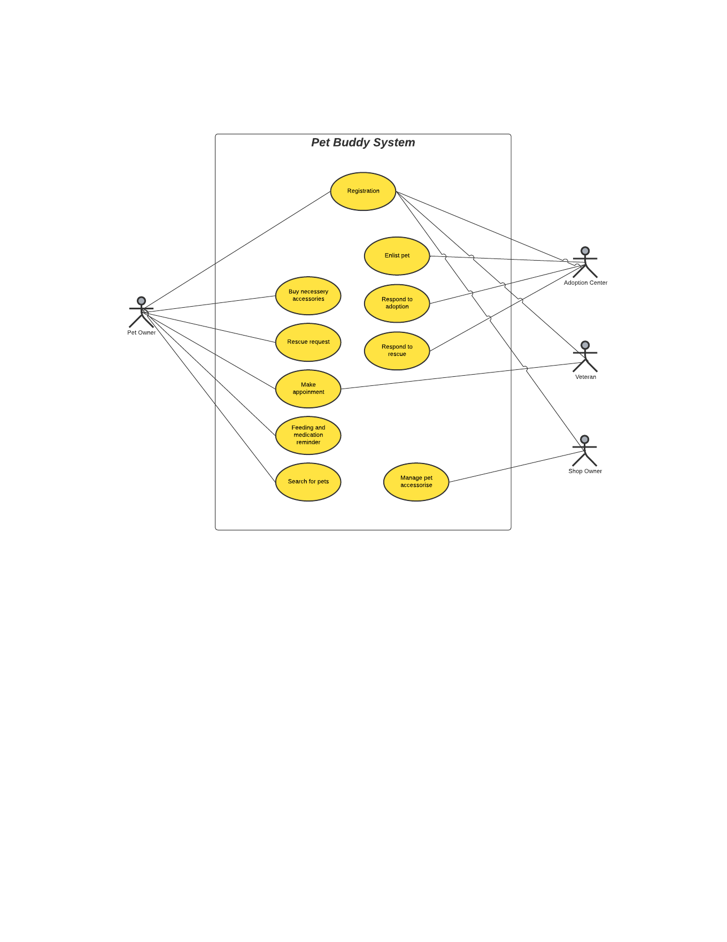**QA4 -****Testability***: The system should be easy to test and find defects.***QA5 -****Flexibility:** *The system should be flexible enough to be modified.*

## System Interface

Diagram 1 : Use Case Diagram

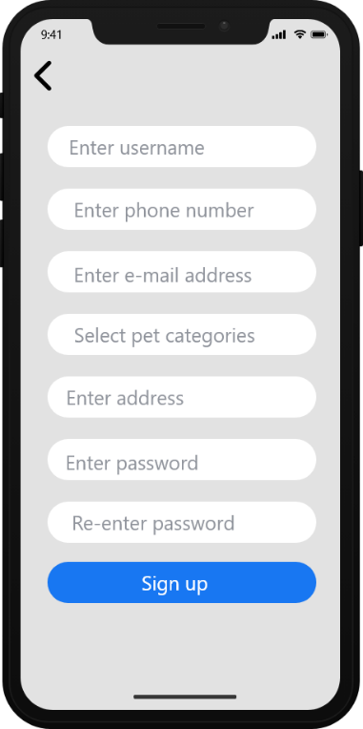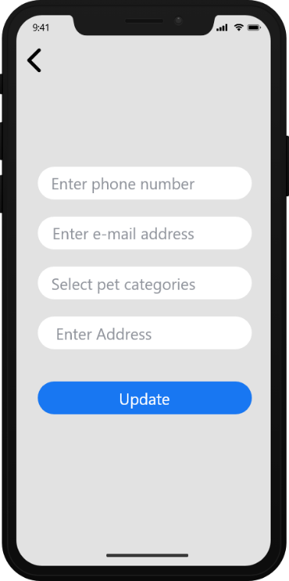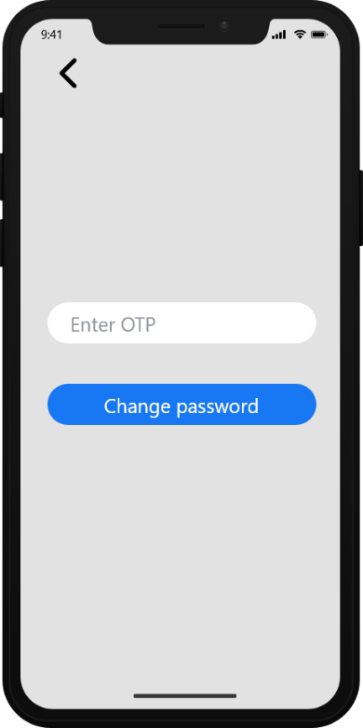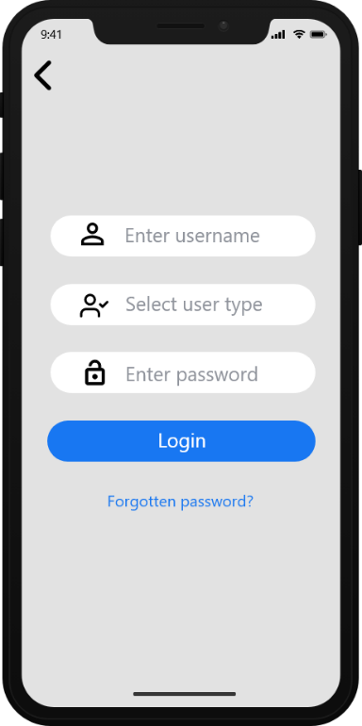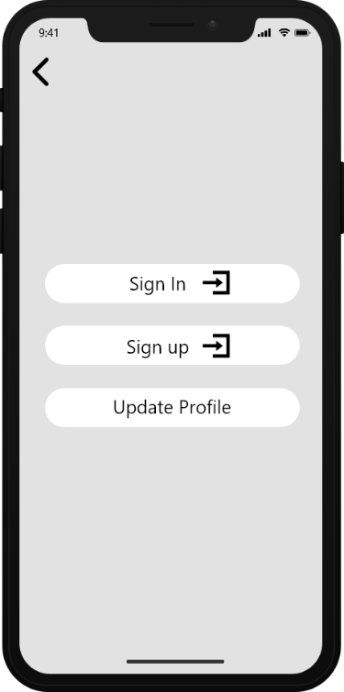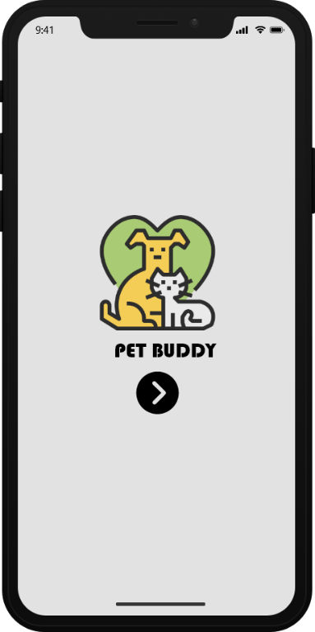  
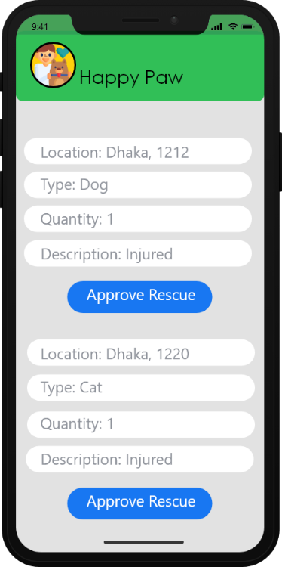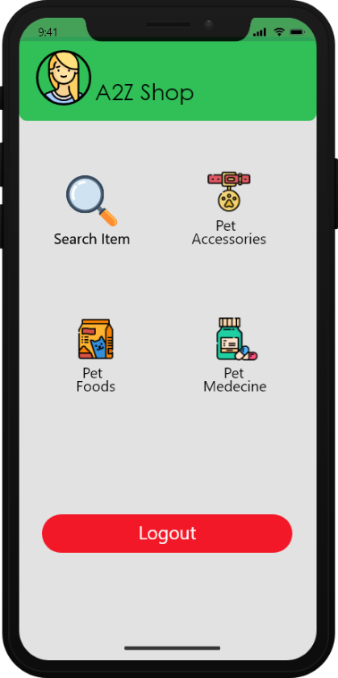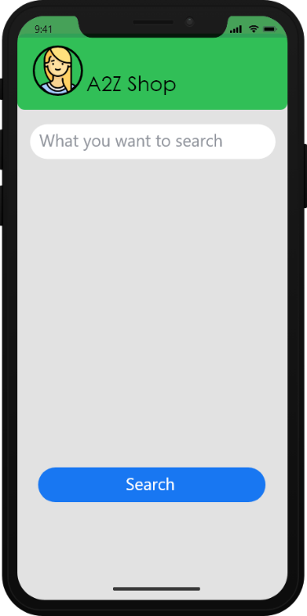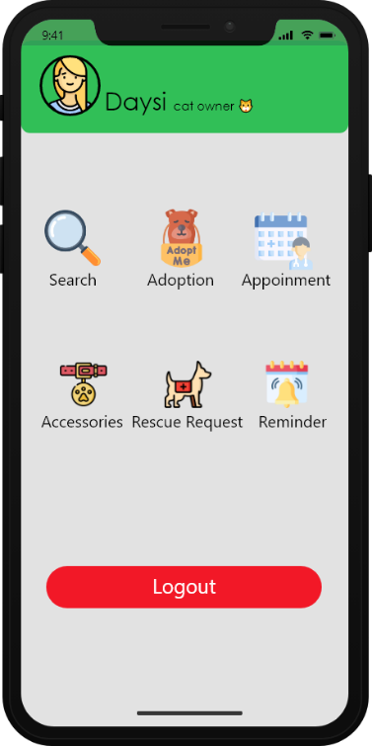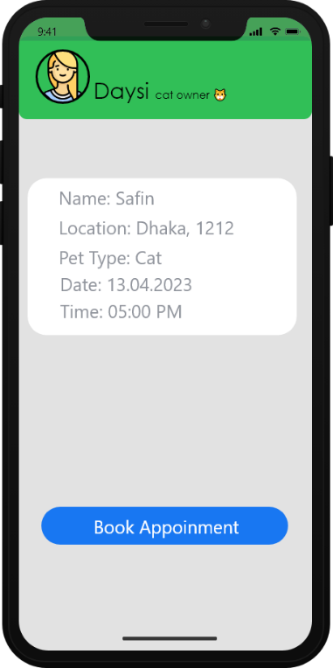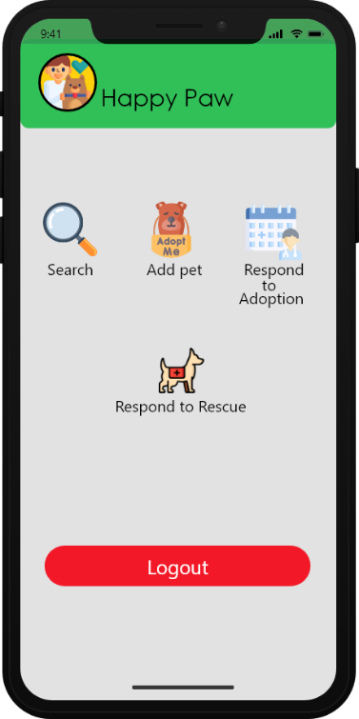  
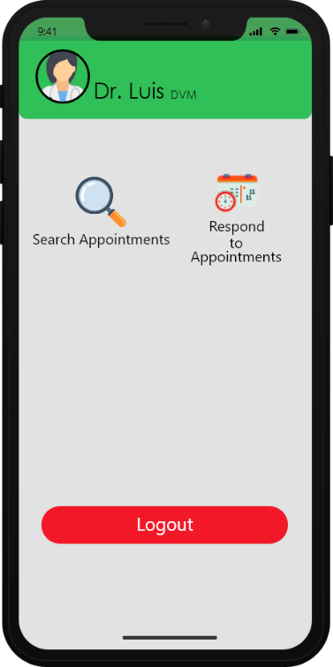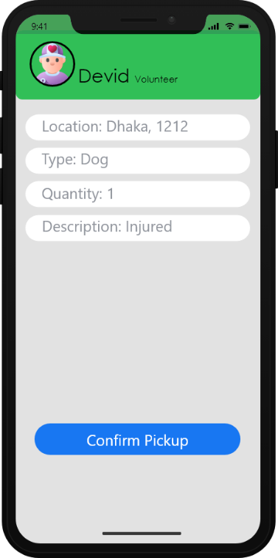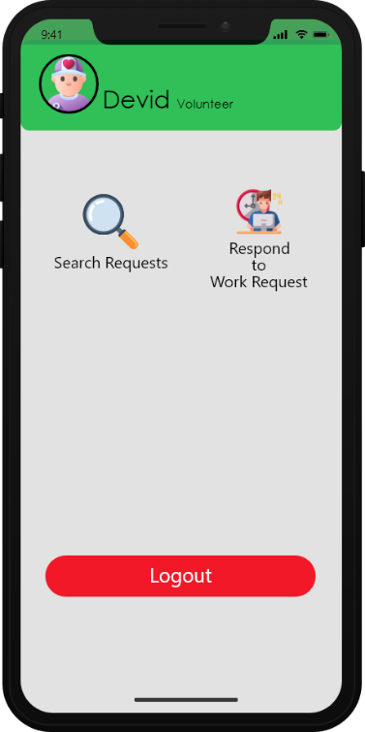

Figure 1.4 : User’s create Figure 1.5 : User’s account Figure: 1.6 : Password   
 account screen. update screen. change screen.

Figure 1.1 : App launch screen. Figure 1.2 : Sign-in & sign-up Figure: 1.3 : Login screen.  
 screen.

Figure 2.0 : Adoption center’s Figure 2.1 : Shop owner Figure: 2.3 : Shop   
 owner screen. home screen. search screen.

Figure 1.7 : Pet owner’s Figure 1.8 : Pet owner’s book Figure: 1.9 : Shop owner   
 home screen. appointment screen. home screen.

Figure 2.4 : Volunteer Figure 2.5 : Volunteer Figure: 2.6 : Veterinarian   
 home screen. requests screen. home screen.

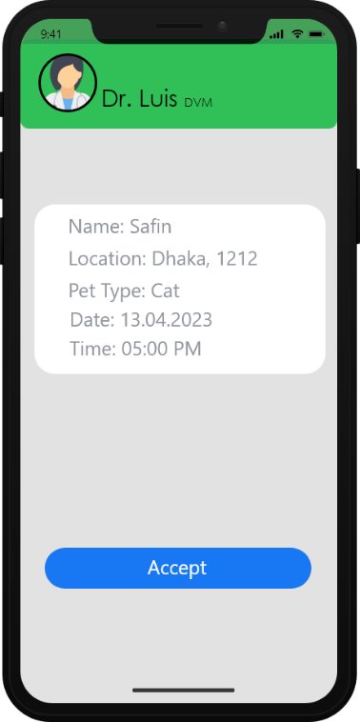

Figure 2.7 : Veterinarian appointment   
 list screen.

## Project Requirements

* Constructive Cost Model:

Software Project Type: Organic   
Coefficient<Effort Factor> = 2.4   
So, P = 1.05 and T = 0.38   
SLOC = 20000 Lines   
  
Persons-months, PM = Coefficient * (SLOC/1000) ^P   
 = 2.4 * (20000 /1000) ^1.05   
 = 55.75

Development time, DM = 2.50 * (PM)^T   
 = 2.50 * (55.75) ^0.38   
 = 11.52   
 = 12 months   
 = 1440 Working hours in total (Per week 30 hours)

Required number of total people, ST = PM/DM   
 = 55.75/12   
 = 4.64   
 = 5 people

* Total Budget:  
    
  Developer/Tester salary of 12 months:   
  Per employee salary per month = 30,000 Taka = 250 Taka per hour   
  Total salary = 250 * 1440 = 3,60,000 Taka   
    
  Requirement analysis:   
  Required time = 1 month = 22 working days = 176 working hour   
  Requirement analysis person’s per hour salary = 150 Taka   
  Total requirement analysis salary = 150 * 176 = 26,400 Taka   
    
  Transportation cost:   
  10,000 Taka (Approximate)   
    
  Hardware expense:   
  1,50,000 Taka (Approximate)   
    
  Rent expenses:  
  Room per month = 15,000 Taka   
  Total in 12 months = 12 * 15,000 Taka = 1,80,000 Taka   
    
  Project manager’s salary of 12 months:   
  Per month salary = 33,000 Taka   
  Total salary = 33,000 * 12 = 3,96,000 Taka   
    
  Total expense: 3,60,000 + 26,400 + 10,000 + 1,50,000 + 1,80,000 + 3,96,000 = 11,22,400 Taka Profit: 30% of total expense = 11,22,400 * 30% = 336,720 Taka   
  Total budget: 11,22,400 + 336,720= 1,459,120 Taka

# FEATURES NOT TO BE TESTED

* Hardware
* Network

# TESTING APPROACH

## Testing Levels

The "Pet Buddy" project will undergo unit testing, system testing, integration testing, and acceptance testing.  Indeed, with the fixed budget and timeline, most testing will be carried out by the test manager, with the cooperation of the development teams.

* **Unit Testing:** During this phase, the developer will test each small software module on a regular basis. Some approaches will be used by the programmer to review the code line by line. It will be white box testing with no code execution.
* **Integration Testing:** In this module individual small software modules or components of a software application will be tested as a combined entity. performed after unit testing, which verifies the functionality of individual modules. Integration testing involves testing the interactions between these modules and ensuring that they work as expected when combined. It will be don’t by the tester.
* **System Testing:** During this phase, System testing will be conducted to evaluate the entire software system or product, ensuring that it meets the specified requirements and works as expected in the intended environment. It will be performed after integration testing; it will also be done by the tester.
* **Acceptance Testing:** In this last phase of testing acceptance testing will be conducted determine whether the software system meets the requirements and specifications of the stakeholders and whether it is ready for deployment. It may involve testing by end-users, stakeholders, or other individuals who will be using the software system in the actual environment.

## Test Tools

* The Selenium software will be used to automate the testing. Selenium is an open-source umbrella project for a range of tools and libraries aimed at supporting browser automation. It provides a playback tool for authoring functional tests across most modern web browsers, without the need to learn a test scripting language.
* The TestRail software will be used to test case management. It helps to organize testing efforts and get real-time insights into testing activity.
* Jira project management tool will be used to manage the project, workflows. It is primarily used for agile software development and provides a range of features that help teams to plan, track, and manage work.
* GANTTPRO tool will be used to illustrates a project schedule.

## Meetings

The test team will meet once or twice in a week to evaluate the progress and detect error and issues as soon. Every two weeks, the test team leader will meet with development and the project manager. These two meetings will take place in different weeks. In the event of an emergency, more meetings may be scheduled.

# TEST CASES/TEST ITEMS

|  |  |  |  |  |  |
| --- | --- | --- | --- | --- | --- |
| Project Name: Pet Buddy | | | Test Designed by: Safin | | |
| Test Case ID: TC_01 | | | Test Designed date: 03/04/2023 | | |
| Test Priority (Low, Medium, High): High | | | Test Executed by: | | |
| Module Name: Registration | | | Test Execution date: | | |
| Test Title: verify registration with valid information | | |  | | |
| Description: Test registration page | | |  | | |
| Precondition (If any): User must have given valid information | | | | | |
| Test Steps | Test Data | Expected Results | | Actual Results | Status (Pass/Fail) |
| 1. Navigate to the system. 2. Fill-up required field. 3. Click submit | Valid username and password. | User should be able to register successfully. | | As expected, | Pass |
| Post Condition: After the completion of registration all the given information will be stored in a database to log-in to the system. | | | | | |

|  |  |  |  |  |  |
| --- | --- | --- | --- | --- | --- |
| Project Name: Pet Buddy | | | Test Designed by: Safin | | |
| Test Case ID: TC_02 | | | Test Designed date: 03/04/2023 | | |
| Test Priority (Low, Medium, High): High | | | Test Executed by: | | |
| Module Name: Login | | | Test Execution date: | | |
| Test Title: verify login with valid information | | |  | | |
| Description: Test Login page | | |  | | |
| Precondition (If any): User must have given valid information | | | | | |
| Test Steps | Test Data | Expected Results | | Actual Results | Status (Pass/Fail) |
| 1. Navigate to the system. 2. Fill-up required field. 3. Click login | Valid username and password. | User should be able to login successfully. | | As expected, | Pass |
| Post Condition: Users given information will be validated with database. | | | | | |

|  |  |  |  |  |  |
| --- | --- | --- | --- | --- | --- |
| Project Name: Pet Buddy | | | Test Designed by: Safin | | |
| Test Case ID: TC_03 | | | Test Designed date: 12/04/2023 | | |
| Test Priority (Low, Medium, High): Medium | | | Test Executed by: | | |
| Module Name: Search functionality test | | | Test Execution date: | | |
| Test Title: verify search for pets | | |  | | |
| Description: Test system search option | | |  | | |
| Precondition (If any): User must log in to the system | | | | | |
| Test Steps | Test Data | Expected Results | | Actual Results | Status (Pass/Fail) |
| 1. Launch the system page. 2. Navigate to the search option on the system page. 3. Enter a valid search query in the search bar. 4. Click the search button. | Valid search query: "cat"  Invalid search query: "1234" | User should be able to search pet successfully. | | As expected, | Pass |
| Post Condition: After searching the system shows the required pet information to the user | | | | | |

|  |  |  |  |  |  |
| --- | --- | --- | --- | --- | --- |
| Project Name: Pet Buddy | | | Test Designed by: Safin | | |
| Test Case ID: TC_04 | | | Test Designed date: 13/04/2023 | | |
| Test Priority (Low, Medium, High): Medium | | | Test Executed by: | | |
| Module Name: Buy necessary accessories | | | Test Execution date: | | |
| Test Title: verify buy necessary accessories for pets | | |  | | |
| Description: Test system buy page | | |  | | |
| Precondition (If any): User must log in to the system | | | | | |
| Test Steps | Test Data | Expected Results | | Actual Results | Status (Pass/Fail) |
| 1. Navigate to the ShoSSpping   page.   1. Select items for the pets. 2. Click checkout. | Select item | User should be able to buy pets necessary accessories. | | As expected, | Pass |
| Post Condition: After confirming the order the system will shows more related product for the pets. | | | | | |

|  |  |  |  |  |  |
| --- | --- | --- | --- | --- | --- |
| Project Name: Pet Buddy | | | Test Designed by: Nazia | | |
| Test Case ID: TC_05 | | | Test Designed date: 10/04/2023 | | |
| Test Priority (Low, Medium, High): High | | | Test Executed by: | | |
| Module Name: Rescue Request | | | Test Execution date: | | |
| Test Title: verify rescue request | | |  | | |
| Description: Test rescue request page | | |  | | |
| Precondition (If any): User must log in to the system | | | | | |
| Test Steps | Test Data | Expected Results | | Actual Results | Status (Pass/Fail) |
| 1. Navigate to the Requesting   page.   1. Enter rescue details. 2. Click request. | Provide information about the pet.  Provide location of the pet. | User should be able to place a rescue request successfully. | | As expected, | Pass |
| Post Condition: After submitting the rescue request the system should showed a massage to the user. | | | | | |

|  |  |  |  |  |  |
| --- | --- | --- | --- | --- | --- |
| Project Name: Pet Buddy | | | Test Designed by: Nazia | | |
| Test Case ID: TC_06 | | | Test Designed date: 10/04/2023 | | |
| Test Priority (Low, Medium, High): High | | | Test Executed by: | | |
| Module Name: Respond to rescue | | | Test Execution date: | | |
| Test Title: verify rescue respond | | |  | | |
| Description: Test response to rescue page | | |  | | |
| Precondition (If any): User must log in to the system | | | | | |
| Test Steps | Test Data | Expected Results | | Actual Results | Status (Pass/Fail) |
| 1. Navigate to the Requests   page.   1. Click rescue details. 2. Click accept. | Select accept | User should be able to accept the rescue request. | | As expected, | Pass |
| Post Condition: After accepting the system should showed other requests. | | | | | |

|  |  |  |  |  |  |
| --- | --- | --- | --- | --- | --- |
| Project Name: Pet Buddy | | | Test Designed by: Israt | | |
| Test Case ID: TC_07 | | | Test Designed date: 03/04/2023 | | |
| Test Priority (Low, Medium, High): High | | | Test Executed by: Israt | | |
| Module Name: Respond to adoption | | | Test Execution date: | | |
| Test Title: approve adoption request | | |  | | |
| Description: Test pet adoption request | | |  | | |
| Precondition (If any): User must log in to the system | | | | | |
| Test Steps | Test Data | Expected Results | | Actual Results | Status (Pass/Fail) |
| 1. Navigate to the Adoption   page.   1. Click rescue details. 2. Click approve. | Pet adoption request | User should be able to accept the adoption request. | | As expected, | Pass |
| Post Condition: After submitting the approve the system should showed other adoption requests. | | | | | |

|  |  |  |  |  |  |
| --- | --- | --- | --- | --- | --- |
| Project Name: Pet Buddy | | | Test Designed by: Israt | | |
| Test Case ID: TC_08 | | | Test Designed date: 11/04/2023 | | |
| Test Priority (Low, Medium, High): Medium | | | Test Executed by: | | |
| Module Name: Enlist a pet | | | Test Execution date: | | |
| Test Title: Enlist a pet with all information into the   system. | | |  | | |
| Description: Add pets with detail information into the   system. | | |  | | |
| Precondition (If any): User must log in to the system | | | | | |
| Test Steps | Test Data | Expected Results | | Actual Results | Status (Pass/Fail) |
| 1. Navigate to the enlist page. 2. Fill necessary information. 3. Click add. | Valid information for enlist a pet into the system. | User should be able to add a new pet into the system. | | As expected, | Pass |

|  |  |  |  |  |  |
| --- | --- | --- | --- | --- | --- |
| Project Name: Pet Buddy | | | Test Designed by: Asif | | |
| Test Case ID: TC_09 | | | Test Designed date: 11/04/2023 | | |
| Test Priority (Low, Medium, High): Medium | | | Test Executed by: | | |
| Module Name: Feeding and medication reminder | | | Test Execution date: | | |
| Test Title: Feeding and medication reminder for pets. | | |  | | |
| Description: Feeding and medication reminder will be   showed as per the time. | | |  | | |
| Precondition (If any): User must log in to the system | | | | | |
| Test Steps | Test Data | Expected Results | | Actual Results | Status (Pass/Fail) |
| 1. Navigate to the reminder page. 2. Set when to give the alert. 3. Click save. | Valid information alert. | User should be able to set an alert for feeding and medicate the pets on time. | | As expected, | Pass |
| Post Condition: After setting the alert for feeding and medication the system should shows all the” alert that has been set”. | | | | | |

|  |  |  |  |  |  |
| --- | --- | --- | --- | --- | --- |
| Project Name: Pet Buddy | | | Test Designed by: Asif | | |
| Test Case ID: TC_10 | | | Test Designed date: 15/04/2023 | | |
| Test Priority (Low, Medium, High): Medium | | | Test Executed by: | | |
| Module Name: Make appointment | | | Test Execution date: | | |
| Test Title: Make appointment with veteran. | | |  | | |
| Description: Pet owners can easily make an appointment with the veteran. | | |  | | |
| Precondition (If any): User must log in to the system with valid username and password. | | | | | |
| Test Steps | Test Data | Expected Results | | Actual Results | Status (Pass/Fail) |
| 1. Navigate to the appointment page. 2. Set when to make the appointment. 3. Click submit. | Valid name, date, contact information | User should be able to book an appointment with a veteran. | | As expected, | Pass |
| Post Condition: After successfully make an appointment the system will show a details appointment information. | | | | | |

# ITEM PASS/FAIL CRITERIA

Before proceeding to the next phase of testing, the entry criteria for each stage must be met. The criteria for passing and failing have been listed below:

* If the requested page does not show after submitting a request in the system, it will be considered a failure case.
* If the predicted result occurs in the given scenario, the design will be considered pass; otherwise, the criteria should be failed.

# TEST DELIVERABLES

* Acceptance test plan
* Integration test plan
* System test plan
* Unit test plans
* Screen prototypes
* Report mock-ups
* Separate test plans for every phase of the testing cycle
* Defect reports and summaries
* Test logs and turnover reports

# STAFFING AND TRAINING NEEDS

* Project Manager: Responsible for the entire project's execution. This includes creating requirements, managing the testing cycle, and so on. As a result, project managers must be skilled in these areas.
* Test Engineer: Responsible for test planning, test methods development, test information creation, and test execution, as a result, test engineers must be capable of planning and executing any test case using automated technologies.
* Test Manager: Responsible for developing expert test strategies, evaluating test deliverables, managing test cycles, and determining whether testing is complete. As a result, test managers must be trained in the evaluation of professional standard test plans.

# RESPONSIBILITIES

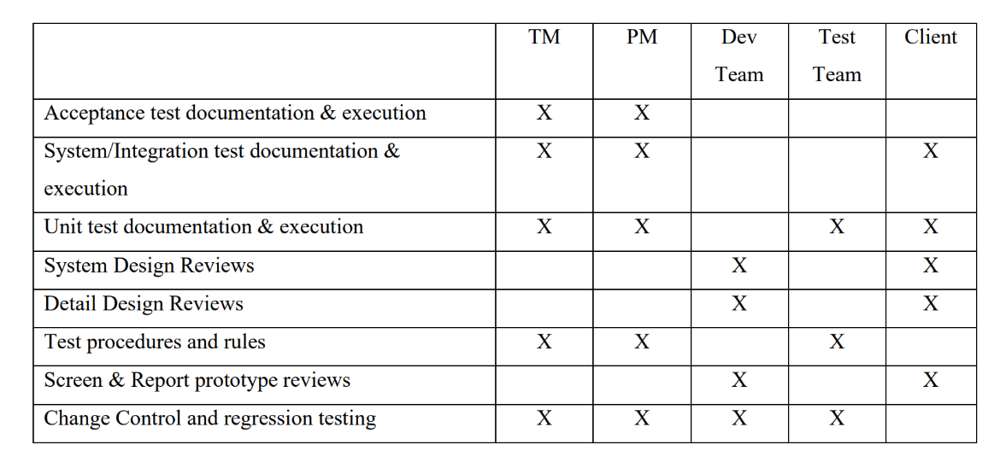

# TESTING SCHEDULE

Activity key:

A : Documentation

B : Design

C : Unit testing

D : Integration testing

E : System testing

F : Acceptance testing

G : Prototype

H : Code implementation 1

I : Code implementation 2

J : Code implementation 3

K : Deliver and feedback

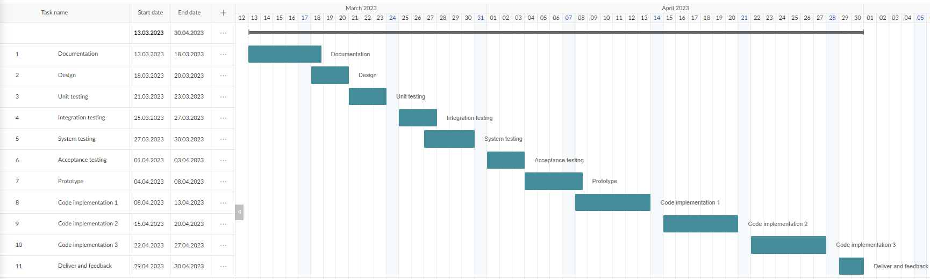

# PLANNING RISKS AND CONTINGENCIES

* Determine the risks and triggers.
* Categorize and prioritize all risks.
* Keep an eye out for risk triggers throughout the project.

# APROVALS

|  |  |
| --- | --- |
| Project Sponsor – Md. Safin | Approved |
| Development Management – Nazia Hassan | Approved |
| EDI Project Manager – Israt Sharmin | Approved |
| RS Test Manager – Md. Asif Chowdhury | Approved |
| RS Development team Manager – Md. Safin | Approved |
| Reassigned Sales – Nazia Hassan | Approved |
| Order Entry EDI Team Manager – Md. Asif Chowdhury | Approved |